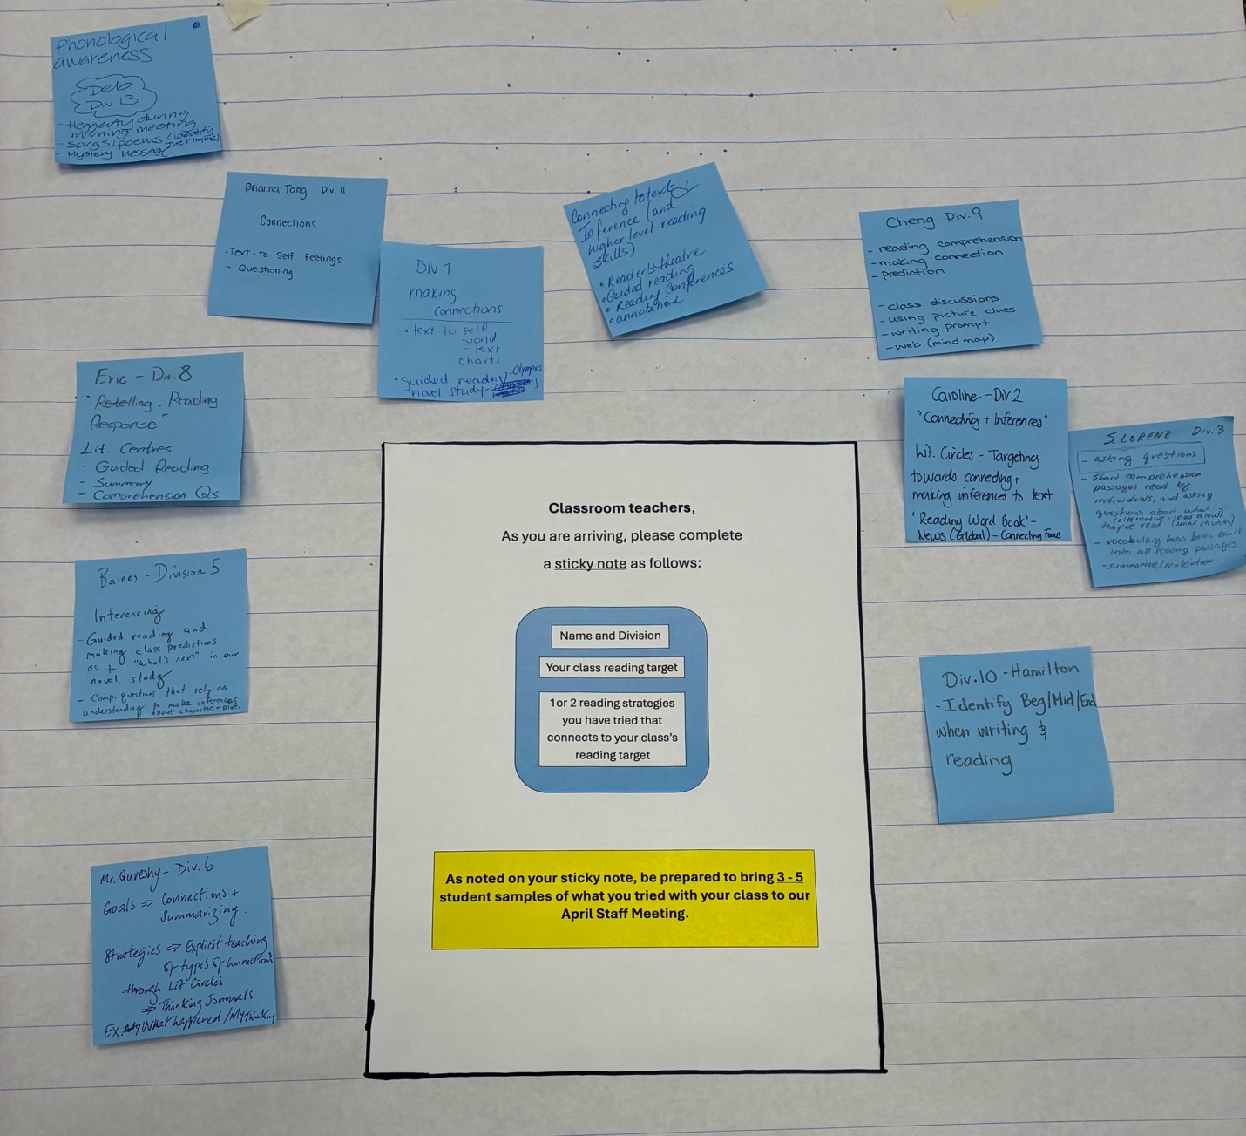
- At our recent staff meeting, March 2nd, staff took a minute to jot down their thinking about what reading strategies they have tried based on data they collected in Term 1

  - Each teacher has addressed one reading target for the school year based on the data gathered from our October RFRA (Richmond Formative Reading Assessment).

  - After our Professional Learning Day, we had a teacher consultant come support staff in thinking about strategies that would support colleagues in how to approach lesson sequences and identify a place to start using our Pillars of Literacy as a possible resource.

- The photo notes what reading strategy(ies)classroom teachers have tried to date.

- At the April staff meeting, colleagues have been asked to bring 2-3 student samples based on the strategy they have tried, so we can work in grade groups to share out and discuss what we notice in student learning.

