**2025/2026 Grade 5 Active! Pass**

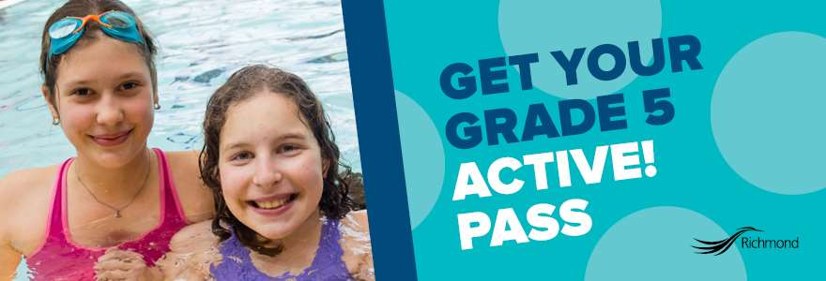

**It's time to register for a school year of free, active fun!**

All Richmond kids in grade 5, including those home-schooled or attending private schools, can pick up a pass today.

Each Pass includes **FREE** admission until June 30, 2026 to:

* Drop-in public swimming at Minoru Centre for Active Living and Watermania
* Drop-in public skating at Richmond Ice Centre and Minoru Arenas (skate rentals are an extra fee)
* West Richmond Pitch & Putt with a paying adult (rentals are an extra fee)
* Various drop-in programs at local community centres (check back for details)

**It's also simple to register!**

Grade 5 students just need to bring the following to a local recreation centre:

* birth certificate or passport showing they are 10 years old as of December 31, 2025; and
* proof of residency or City of Richmond Grade 5 confirmation letter received in school in October.