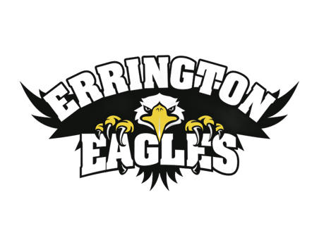**Week-At-A-Glance**

**WAAG for Errington Families**

**February 10th – 14th, 2025**

**Reminder of Possible Weather Related School Closures:**

**As the cold weather continues, we are reminded of the District’s “Weather Related School Closures” guidelines. Once again, notices of school closure will be posted on the School District’s SD38.bc.ca web-site and on social media by 6:30 am. We will email all families directly as soon as possible. We will also post this info on our Errington school website.**

**Our Awesome “Young Actors Project” Finishes Up This Monday February 10th**

**Thanks again to Ms. Hamilton for organizing these theatrical / dramatic arts workshops for our primary classes and to “Maestro”, our amazing drama instructor for making these sessions so much fun!**

**Connects Day 2 Coming This Tuesday February 11th:**

**We are looking forward to the second Connects day for our Intermediate students. As we mentioned last week, if there is a school closure on Monday, we would still go ahead with plans for the Connects activities. If school were closed on Tuesday, then we would cancel our plans for these activities - and do our best to reschedule if possible. *A reminder that students who are registered for skiing / snowboarding are to arrive at Errington by 7:45 am.***

**Red, Pink And White Valentines/ Friendship Day on Thursday February 13th.**

**On Thursday February 13th, our Student Council is promoting a “Red, Pink and White Valentines / Friendship Day”. Student are encouraged to wear red, pink, and/or white on the day before Valentines. (Feb 14th is a Pro-D Day). Our staff have also planned for this day to be the day to kick off an 8 day school-wide focus on Kindness and our new CARES acronym which is meant to teach, promote, encourage and celebrate “Caring, Accountable, Respectful, Empathetic, and Safe” behaviours within our community. Students will participate in classroom activities that highlights ways for us to be kind to one another and show each other CARES actions. This focus culminates with our annual Pink Shirt “Bullying Awareness / Lift Each Other Up Through Kindness” Day on February 26th.**

**PAC Lunar New Year Raffle Raised Over $1400 This Year**

**Thank you to our amazing PAC for their time and effort to organize a fun and exciting fundraiser to celebrate the Lunar New Year. Our Raffle Draw was help on-line for families to view – and over 40 prizes were awarded at the end of the day today!**

***Please see the attached list of winners in this year’s Lunar New Year Raffle.***

<https://teams.live.com/meet/9370505467105?p=uRLEdc5UhOp5VCfmb1>

**Future Dates, Upcoming Special Events & Highlights Coming Our Way**

* **Monday February 10tH**
* **Monday February 17th Family Day Holiday**
* **Thursday February 20th PAC Meeting: 9:15 – 10:15 am**

**PAC Sushi Lunch**

* **February 24th to 27th Parent Teacher Learning Updates This Week**
* **Tuesday February 25th Early Dismissal for Parent Teacher Learning Updates**
* **Wednesday February 26th Pink Friendship Day: Assembly then Family Teams – times TBA**
* **Friday February 28th PAC Movie Night: 5:30 – 7:30 pm**
* **Friday March 14th Last Day Before Spring Break**

**Highlights for this Week Include:**

|  |  |
| --- | --- |
| **Monday**  **F**eb 10th | * **Boys Basketball Practice at 8:00 am in the gym** * **Young Actors Project For Primary Students: Last Day** * **Hot Dog Lunch Day** * **Knitting Club at lunch: in Library / Div 10** * **Girls Basketball Game: After school at Wowk** |
| **Tuesday**  **F**eb 11th | * **Errington Connects Activities for Intermediate Students– Day 2** |
| **Wednesday**  **F**eb 12th | * **Boys Basketball Practice at 8:00 am in the gym** * **Band Concert by Divisions 1 to 4: at 1:00 pm in the gym for parents of Div 1 to 4**   + ***Thanks to Ms. Stephens, our wonderful Band Teacher, for offering this Concert to the families of these Intermediate classes*** * **Girls Basketball Home Game: After school vs Blundell** |
| **Thursday**  **F**eb 13th | * **Red, Pink, and White Valentines Friendship / Kindness Day at Errington**   + **Students encouraged to wear red, pink, and/or white** * **Girls Basketball Practice at 3:00 pm in the gym** |
| **Friday**  **F**eb 14th | * **Pro-D Day for Staff: District-wide Non-Instructional Day for students** * **Monday, February 17th is our BC Family Day Holiday:**    + **We hope our students (and families) enjoy their 4-day weekend** |