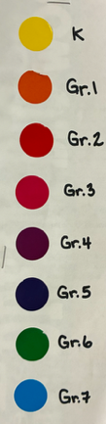
KEY: Grades by color

I LOVE TO READ: I LIKE TO READ:
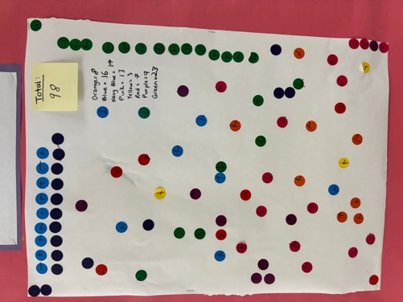
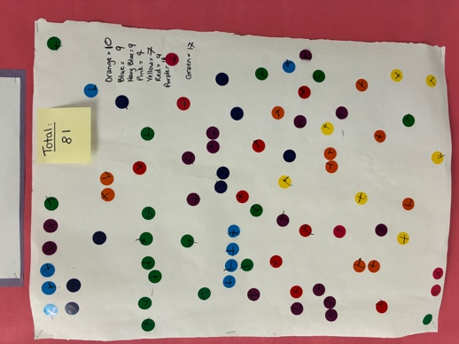
Primary = 38% Primary = 33%
Intermediate = 62% Intermediate = 67%

I READ SOMETIMES: I DO NOT LIKE TO READ:
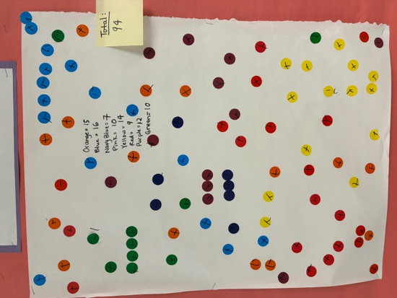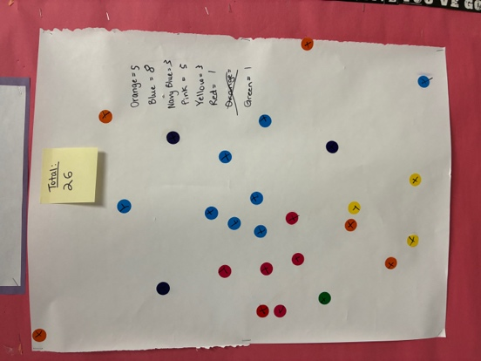
Primary = 51% Primary = 48%
Intermediate = 48% Intermediate = 46%

